Texas Firefighter Olympics Bass Tournament

We will be fishing Lake Nocona, which is east of Wichita Falls, 8 miles northeast of Nocona, TX. Tournament times will be from 6am–3pm on July 21and 22, 2003.

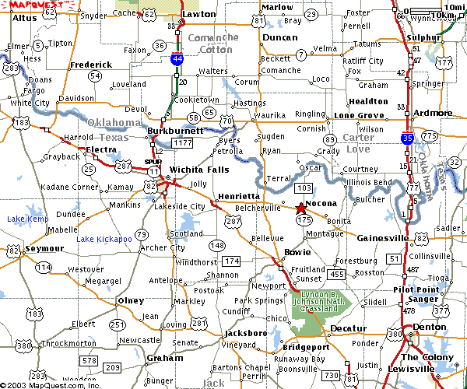

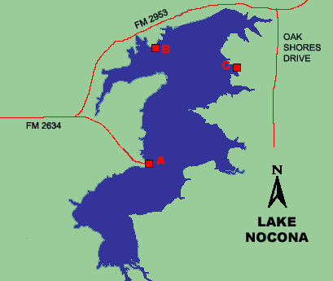
Lake Nocona Point A: Weldon Robb Park
- Located at mid-lake at the end of FM 2634. From Nocona, take FM 103 north and turn east on 2634.
- No fee required
- Any ramp may be used, but all boats will have to be inspected and take off at the official weigh in site in a numbered order.

